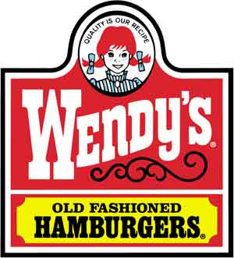

Wendy’s Analysis
Khalid Al-Ajmi
Neil Commerce
Terrell Matthews
Anil K Cheerla

MBAD 271: Strategic Management
Professor Gary Bojes

Table of Contents

Executive Summary 3
Background 4
Mission Statement 4
Vision Statement 4
Analysis of Strengths: 5
Strength 1 5
Strength 2 6
Strength 3 7
Analysis of Weaknesses 8
Weakness 1 8
Weakness 2 9
Weakness 3 10
Summary of Strengths and Weaknesses 11
Internal Factors Framework 12
Three Core Elements of Wendy’s / Arby’s Strategy: 14
Scope: 14
Distinctive Competencies: 14
Competitive Advantage: 14
SWOT Analysis Matrix: 15
Internal-External Matrix: 17
Grand Strategy Matrix: 18
SPACE Matrix Analysis: 19
PARTS Analysis: 21
Count Summary Analysis: 22
Further Analysis 23
The Strategy 23
The Strategy Map 24
Financial Perspective 24
Customer Perspective 25
Internal Perspective (Operations) 26
Learning and Growth Perspective 27
Appendix 1-Strategy Map 29
Appendix 2- Balanced Scorecard 30

Executive Summary

Wendy’s historically has fared very well within the fast-food industry; they have led or been the front runners in a number of key areas that are of extreme importance to customers. However, while Wendy’s has excelled since inception and been a key member in the big four of the fast-food industry inclusive of Wendy’s, McDonalds, Burger King, and YUM Brands, there are a number of area’s that Wendy’s could improved upon and areas of focus the company should examine more deeply in order to create stronger barriers of entry, to gain more market share, and to ensure that they can continue to grow, expand, and remain relevant even during economic hard times as the world and particularly their industry becomes more globalized. Wendy’s at this time however is in the process of refocusing on its core business function which is providing quality hamburgers and meals. Wendy’s currently has merged with Arby’s and recently spun off their interest in Tim Horton’s and sold their interest in Baja Fresh, two focus on the two brands and providing quality food and excellent service. The purpose of this report is to develop a SWOT analysis (to aid in identifying strategies to be undertaken by the company), Strategy Map (to guide in the implementation of these strategies) and Balanced Score Card (to measure the successful implementation of these strategies). These will provide the framework for highlighting the firm’s opportunities and weaknesses while also pointing out how the firm can improve and integrate their operations and customer service with respect to financial, customer, and learning and growth perspectives.

The recent acquisition of Arby’s by Wendy’s will further enhance the potential for economic value added vis – a – vis the current strategy followed by Wendy’s. The niche market provided by Arby’s, i.e. roast beef sandwiches, will provide a broader menu base and further diversify the current menu line. Wendy’s current strategy is one that adheres to high quality offerings as well as competitive service. That's a platform Wendy’s can continue to build upon to differentiate itself from the competitors. Quality is Wendy’s platform and the Wendy’s icon stands for wholesome authenticity and honest quality. Wendy’s has never compromised on quality by slashing prices to cheapen the value of products and tarnish its image. Wendy’s is known for its Wendy's superior quality and great-tasting products.
When compared to the competition, Wendy’s distinguishes itself by strictly adhering to its core competency, i.e. old – fashioned hamburgers. In other words, it does not experiment with new offerings and randomly diversify its menu line unless the offerings create economic value added or enhance the current menu line. Moreover, although Wendy’s global expansion and market share growth efforts trail the competition, its brand name, service quality, and ultimately the food quality help Wendy’s maintain its overall competitiveness and market positioning. The three core elements of Wendy’s/Arby’s strategy in terms of scope, distinctive competencies, and competitive advantage will help one further understand the nature of Wendy’s strategy as well as draw conclusions as to how Wendy’s manages its enterprise.

Background

Wendy’s now known as the Wendy’s/Arby’s Group after the recent merger of the two companies now comprises the third largest quick service restaurant company and is comprised of the two brands Wendy’s and Arby’s, generate about $12 billion in system wide sales and comprise over 10,000 restaurants. The industry as whole is dominated by what is termed the “big four” which comprises McDonalds, Burger King, Wendy’s/Arby’s Group, and Yum Brands. Currently, McDonalds has gained the most attention among businesses within the quick service industry which is shown through their strong advantage in market penetration as well as total revenue, while the Wendy’s has been generally recognized as the leader in quality and customer service.
Wendy’s started out as a single store in downtown Columbus, Ohio and from inception was born placing utmost importance on providing quality so much in fact that founder Dave Thomas put the phrase “quality is in our recipe” was placed in their logo. Today, there are approximately 6,600 Wendy’s restaurants in operation in the United States and in 21 other countries and territories. Wendy’s has seen slow but steady growth but financially and intuitionally, since their start in 1969 by reaching the milestones of going public in September of 1976, going global in 1988, and reaching 5000 stores by march of 1997.

Mission Statement

Wendy's Mission Statement is, "Do the Right Thing!" By doing the right thing, it incorporates People Excellence within its culture. Applaud your people. Model the behavior you want. Involve others. Grow leaders. Yield -- be flexible. We at Wendy's strive every day to uphold and implement the standards and morals that our founder, Dave Thomas, instilled in the Wendy's name: Doing it "Dave's Way!" "Here we never cut corners!" We, along with Dave, truly believe we are the "Employer of Choice," and you will, too.

Vision Statement

To continuously grow stakeholder value by leveraging the strengths of vibrant, independent restaurant brands.

Analysis of Strengths:

Strength 1
Description: | Brand Name, Trademark and Goodwill
Res./Cap.?  Why? | Resource, this is something they have built up over the years and can draw upon to gain competitive advantage
Valuable? Why? | Yes. Customers seek distinct menu items produced by Wendy’s. Also, rivals could not easily replicate the items.
Rare?  Why? | Yes. In the quick serve industry, Wendy’s is the only company with any appreciable brand loyalty.
Imitable?  Why? | No. As industry is in mature phase, it would take massive investment from competitors to imitate.
Substitutable? Why? | No. As stated, Wendy’s is the only restaurant in it’s industry group with any appreciable brand loyalty.
R&C Type?  Why? | Multiple R&C’s
Driver type?  How? | Differentiation Driver. Wendy’s distinguishes its brand name and meal products form the competition.
Value chain location?  Why? | Logistics and marketing as they both tend to support each other in elevating the Wendy’s brand name.
How important is it to the company? | Vitally important, as customers become attached to the Wendy’s brand name due to its differentiated products.
How well is the company addressing it? | Always maintaining image and protecting reputation.
Overall conclusion: | Wendy’s brand name has created substantial goodwill and has established a broad customer base to help sustain its market share

Strength 2
Description: | Cost and operational efficiency
Res./Cap.?  Why? | Capability, they can produce goods at a lower cost than competitors
Valuable? Why? | Yes, allows for significant savings, higher operating income, and better overall service.
Rare?  Why? | No, all in industry are relatively efficient, Wendy’s is just better at it.
Imitable?  Why? | Yes, provided that competitors can gain the knowledge that Wendy’s possess.
Substitutable? Why? | No. Lower costs mean higher profits.
R&C Type?  Why? | Multiple
Driver type?  How? | Cost Driver. Low labor cost and unit labor costs.
Value chain location?  Why? | Logistics and Operations.
How important is it to the company? | Vital, one of the main focuses of corporate efforts.
How well is the company addressing it? | Successfully. There is always room for improvement, but Wendy’s beats the industry average.
Overall conclusion: | Wendys’ operations and cost efficiencies are indeed strengths that the company possesses as they have helped Wendy’s remain competitive and increase overall market share

Strength 3
Description: | New Product Development
Res./Cap.?  Why? | Capability. It represents the ability to successfully introduce new products on a regular basis.
Valuable? Why? | Yes. The market is to a degree driven by new products that draw customers into the store to try them.
Rare?  Why? | No. All competitors introduce new products regularly
Imitable?  Why? | Yes. Competitors can easily imitate new products.
Substitutable? Why? | No. In this industry, new products are expected, and the continuation of old products would not be competitive.
R&C Type?  Why? | Future R &C
Driver type?  How? | Differentiation. Having a different new product from a competitors might get additional customers in store.
Value chain location?  Why? | Marketing/Operations. The new products must be both produced and publicized.
How important is it to the company? | Moderately. New products do not represent the bulk of sales, but the represent the opportunity to gain loyal customers once they experience Wendy’s.
How well is the company addressing it? | Well. Wendys is perhaps the most active of the companies in the industry when it comes to new product development.
Overall conclusion: | Wendy’s does a good job of introducing new products, and it may account for some of the brand loyalty it enjoys.

Analysis of Weaknesses

Weakness 1
Description: | Market Penetration
Res./Cap.?  Why? | Resource. The access to customers is at stake, and at the moment, Wendy’s lacks that access.
Valuable? Why? | Yes. This is perhaps the best indicator of a company’s health in this industry.
Rare?  Why? | Yes. The companies in the industry with the highest penetration dwarf those with lower degrees.
Imitable?  Why? | Yes. It is simply a matter of expanding in to markets that will bear the store.
Substitutable? Why? | No. Quick serve is primarily a short distance industry, so there must be massive local market penetration.
R&C Type?  Why? | Multiple
Driver type?  How? | Differentiation. The ability to find a store anywhere is the a primary strength of industry competitors.
Value chain location?  Why? | Firm infrastructure and human resources. Franchising is primarily a corporate function, and staffing is a primary aspect of franchising.
How important is it to the company? | Vital. It represents any future corporate growth, as per store improvements are hugely difficult.
How well is the company addressing it? | Poorly. Wendys is an industry laggard.
Overall conclusion: | If Wendy’s hopes to ever compete on a head to head basis with it’s competitors (e.g. McDonald’s) it must be able to gain a foothold both domestically and overseas.

Weakness 2
Description: | Menu Diversity.
Res./Cap.?  Why? | Resource. It deals more with the way the menu currently stands than with menu potential.
Valuable? Why? | Yes. Competitors do a large percentage of their business due to their menu diversity.
Rare?  Why? | No. Most companies within the industry have a relatively diverse menu.
Imitable?  Why? | Yes. It simply requires a menu expansion.
Substitutable? Why? | Yes. Specialization can compete to some degree with diversity.
R&C Type?  Why? | Interim R&C’s.
Driver type?  How? | Differentiation. Various menu items cost roughly the same to make.
Value chain location?  Why? | Marketing/Operations. Creating, preparing, and publicizing the menu would be required.
How important is it to the company? | Moderate. The company does not emphasize a diverse menu (for instance, they do not serve a breakfast menu at all). While it might represent an opportunity to gain more revenue per store, it does not appear to be a priority.
How well is the company addressing it? | Moderate. While Wendy’s does regularly introduce a broad variety of their core food, they do not branch out in to other cuisines, generally.
Overall conclusion: | This could be addressed by opening for breakfast, or by introducing non “hamburger type” items.

Weakness 3
Description: | Training/Management Programs
Res./Cap.?  Why? | Capability. The ability to effectively train and promote managers is something that must be actively worked on at all times.
Valuable? Why? | Yes. Store management is at the heart of corporate performance.
Rare?  Why? | No. Most industry companies have effective management training programs.
Imitable?  Why? | Yes. These programs can be built from the ground up. There are individual secrets, but these can be surmised.
Substitutable? Why? | To a degree. Hiring good managers can substitute, but it is more reliable to develop them from within.
R&C Type?  Why? | Future R&C’s.
Driver type?  How? | Dual. Good management ends up saving costs and produces differentiation.
Value chain location?  Why? | Human resources. This rests entirely within the purview of HR.
How important is it to the company? | Very. Store Management can make or break an individual store, and the individual stores represent the backbone of the store.
How well is the company addressing it? | Moderately well. They do not do a bad job, but competitors are excellent at it.
Overall conclusion: | Wendy’s could draw value from expanding it’s management training program to compete with McDonalds.

Summary of Strengths and Weaknesses
Step 1 | Step 2 |  |  |  |  |  |  |  | Step 3 | Step 4
R&Cs | Static RBV Rating |  |  |  | Dynamic RBV Rating |  |  | Result | R&C Map | Competitive Advantage/Disadvantage
List of R&Cs | Added  Va l ue | Ra r ene s s | Imi t a b i l i t y | Su bst i tut ab i l i t y | Mu l t i p l e  R &Cs | Fu t ur e  R&C | I n t e r f i rm  R&Cs | Strength or Weak-ness for the firm? | Location of R&Cs within the firm’s value chain and on its value net | - Complementarities that support or may lead to competitive advantages?  - Gaps that support or may lead to competitive disadvantages?  - Cost or differentiation or dual competitive advantage?
- Brand Loyalty, Goodwill | Y | Y | N | N | X |  |  | Strength | Logistics/ Marketing | A. Partnerships with entertainment companies  B. Lack of online marketing  C. Differentiation
- Cost/Operational efficiency | Y | N | Y | N | X |  |  | Strength | Logistics/ Operations | A. New Technology  B. Potential R & D deficiencies  C. Cost
- New Product Development | Y | N | Y | N |  | X |  | Strength | Marketing/ Operations | A. Changing customer taste  B. Lack of menu diversity  C. Differentiation
- Market Penetration | Y | Y | Y | N | X |  |  | Weakness | Infrastructure/ HR | A. Recent Merger with Arbys  B. Almost no international presence  C. Differentiation
- Menu Diversity | Y | N | Y | Y |  |  | X | Weakness | Marketing/ Operations | A. New product development  B. Lack of breakfast menu  C. Differentiation
6. Management Training | Y | N | Y | Y |  | X |  | Weakness | HR | A. Higher number of MBA’s being produced.  B. Lack of “Hamburger University” type of facility  C. Dual

Internal Factors Framework

Internal Factors Framework for Wendy’s
Key Internal Factors | Importance Weight | Performance Rating | Weighted Score
Strengths
Brand Name, Trademark Goodwill | 12% | 4 | .48
Cost Effeciency and Operations | 10% | 4 | .40
New Product Development | 12% | 3 | .36
Advertising & Marketing | 10% | 3 | .30
Operating hours | 6% | 2 | .12
Customer Value Proposition | 10% | 4 | .40
Mergers/Acquisitions | 4% | 2 | .08
Weaknesses
Global Market Penetration | 12% | 1 | .12
Domestic Market Penetration | 6% | 2 | .12
Menu Diversity | 10% | 2 | .20
Management/Training | 4% | 2 | .08
Exposure to Market Risk | 4% | 1 | .04
Total | 100% |  | 2.70
The internal factors framework is a valuable tool for determining the degree to which a company is succeeding in addressing the various strengths and weaknesses that the company possesses. Our ratings have Wendy’s performing moderately well (An IFF score of between 2 and 3 correlates to “average”, so Wendy’s score of 2.7 puts them slightly above average). A few key points bear explanation.
We gave Wendy’s a score of 4 on the relatively important “Customer Value Proposition” and that scored well for them overall, but did not include it in our final list of strengths because we felt that it was somewhat included in the “Brand Name, Trademark Goodwill” in that the brand name was valuable in part because customers felt that Wendy’s provides a good value proposition. We did not eliminate it, because it is not the same thing, and bears separate counting, but for the sake of conciseness, we omitted it later.
Despite Wendy’s recent merger with Arby’s, we only gave the company a rating of 2 in the Mergers/Acquisitions category. For it’s history, Wendy’s has largely not combined with competitors, and this has left it in an unenviable position with regard to market penetration. Thus, even though recent history trends otherwise, we scored them relatively low for a strength. Similarly, we only gave them a 2 in “operating hours” because while they are known for being open late in the evening, they do not offer breakfast, and we could not in good conscience grant a 3 or a 4 when they are sacrificing all of that breakfast business. It should be noted that these were the two smallest weighted of the strengths, so this has less of an impact than it might otherwise.
It should also be noted that for the purpose of this analysis, we have separated “Market Penetration” into “Global Market Penetration” and “Domestic Market Penetration”. Although in other parts of the paper they are dealt with as a singular unit, this section gave us an opportunity to really drill down numerically, and it should be noted that Wendy’s has done a better job (if not a job that could be described as “good”) domestically than they have overseas, and this is the reason for the difference in ratings between the two.
Finally, the rating of 2 in menu diversity comes from the fact that while Wendy’s does not generally stray far from the “hamburgers and sandwiches” milieu, it tends to have a relatively wide variety within that category. This relates closely to their strength in new product development. The fact that there are often new items on the menu means that the menu is always diverse, if only to a degree. While still not a strength and something that we could rate a 3 or a 4, it merits more than the abject failure that a 1 seems to indicate.
Three Core Elements of Wendy’s / Arby’s Strategy:

Scope:
The scope of Wendy’s strategy mainly focuses on a certain demographic segment of the population, namely, the adult consumer aged 18 – 35. This demographic is crucial to Wendy’s success as consumers in this age group tend to frequent fast food restaurants more than any other age group. As such, Wendy’s tailors its marketing strategy and its menu line to befit this age group.

Distinctive Competencies:
- New product innovation and improvement.
- Superior product quality on the basis of “fresher, superior ingredients”.
- Innovation and partnerships.
- Location, Low price, Cleanliness, and High value of products.
These various distinctive competencies have enabled the Wendy’s enterprise to sustain its current market position and its overall success. In terms of new product innovation and improvement, Wendy’s consistently introduces new sandwiches at various economic cycles based on ongoing research and development. Also, the “freshness” of all of its food offerings has propelled the Wendy’s group into an aggressively competitive position as all of its ingredients are ensured for safety and “freshness.” Finally, Wendy’s retail locations, competitive pricing structure, and cleanliness are all factors that help retain the current customer base as well as attract potentially new customers.

Competitive Advantage:
- High Quality is a key differentiation factor for Wendy’s. It positions Wendy’s as a premium fast food restaurant with food made to order and fresh.
- Quick and inexpensive way to have a meal
- Elevate the customer experience by utilizing improved people quality

Wendy’s primary competitive advantage derives from the production of high quality sandwiches that are both fresh and made to order. This is a key differentiating factor that allows Wendy’s to maintain its current market share as the most of the other competition does not necessarily adhere to this “freshness” policy. Also, Wendy’s relative quick and inexpensive meals facilitate the retention and attraction of customers. The “people” quality is a further attribute that Wendy’s strategy follows as customer service takes a priority role.
The main conclusion to be drawn from the aforementioned is that Wendy’s differentiates itself from competitors by focusing on superior quality and superior service. It offers fresh salads, fresh-beef burgers and condiments. Combined with an aggressive price structure, Wendy’s seems poised to command significant market share as well as a significantly competitive position.

SWOT Analysis Matrix:
 |  | SWOT Analysis Matrix
 |  |  | Strengths (S) | Weaknesses (W)
 |  |  | - Brand Name, Trademark, & Goodwill. | - Global Market Penetration.
 |  |  | - Cost – Efficiency & Operations. | - Menu Diversification.
 |  |  | - New Product Development | 3. Domestic Market Penetration
 | Opportunities (O) |  | SO Strategies | WO Strategies
 | - Global Expansion. |  | - S1-O1- Target Americans abroad (MKT DEV)  - S2-O2- Build-a-Burger Aisle (PRD DEV)  - S3-O3- “Café Wendy”- featuring upscale/varied fare (CONSEN DIV) | - W1-01- Form partnership w/ local eateries/firms to establish brand (JOINT VEN/MKT DEV)  - W2-O1- Offer local fare in international stores (PRO DEV)  - W2-O3- “Café Wendy”- featuring upscale/varied fare (CONSEN DIV)
 | - Mass Customization
 | - Upscale boutique Stores
 | Threats (T) |  | ST Strategies | WT Strategies
 | - Commoditization |  | - S1-T1- Heavily market quality, seek premium (MKT PEN)  - S2-T1- Build-a-Burger Aisle (PRO DEV)  - S3-T2- Develop “Healthy Fare” menu (PRO DEV) | - W1-T1- Position overseas stores to seek premium market (MKT PEN)  - W2-T2- Develop “Healthy Fare” menu (PRO DEV)  - W2-T2- Purchase competitor known for healthy menu (Quizno’s e.g.) (HOR INT)
 | - Consumer concerns about nutritional content
 | - Government Action
Detailed descriptions of strategies:
SO Strategies | - Intensive Market Development Strategy.  - Intensive Product Development Strategy.  - Defensive Joint Venture Strategy.  - Horizontal Diversification Strategy.  - Horizontal Diversification Strategy.
ST Strategies | - Horizontal Diversification Strategy.  - Backward Integration.  - Intensive Market Penetration.
WO Strategies | - Intensive Market Penetration.  - Defensive Joint Venture Strategy.  - Intensive Product Development Strategy.
WT Strategies | - Horizontal Integration Strategy.  - Intensive Product Development Strategy.  - Backward Integration Strategy.

Overall, Wendy’s needs to pursue a backward integration strategy in order to control rising costs of raw materials and minimize overhead and expenses. Additionally, it will need to pursue an intensive market development strategy in order to maintain its competitiveness. Finally, it will need to consider a joint venture defensive strategy to avoid the loss of market share to new market entrants.

Internal-External Matrix:
 |  |  | Internal-External Matrix
IFF Score
(2.70)
 |  |  |  | Strong  4.0 - 3.0 | Average  3.0 - 2.0 |  | Weak  2.0 - 1.0
 |  |  |  | 4.0 3.0 2.0 1.0
 | CFF Score  (1.85) | Strong 4.0 - 3.0 | 4.0  3.0  2.0  1.0
 | CFF Score  (1.85) | Average 3.0 - 2.0 | 4.0  3.0  2.0  1.0
 | CFF Score  (1.85) | Weak 2.0 - 1.0 | 4.0  3.0  2.0  1.0 |  | Diversification, retrenchment, divestment

The above framework is a reference to specific SWOT strategies that make prudent sense in our overall analysis. Specifically, concentric diversification is an appropriate strategy for Wendy’s as the Wendy’s Café will certainly enhance overall competiveness.

Grand Strategy Matrix:
Dimension | How measure/assess/evaluate? | Result
Competitive Position | Market Share & Market Capitalization | Weak Competitive Position
Market Growth | Acquisitions & New Products | Rapid Market Growth

Exhibit 5-5 |  | Grand Strategy Matrix Analysis
 | Rapid Market Growth
Strong Competitive Position | Quadrant I  - Market development  - Market penetration  - Product development  - Forward integration  - Backward integration  - Horizontal integration  - Concentric diversification |  | Quadrant II  - Market development  - Market penetration  - Product development  - Horizontal integration  - Divestiture  - Liquidation |  | Weak Competitive Position
Strong Competitive Position | Quadrant IV  - Concentric diversification  - Horizontal diversification  - Conglomerate divers'n  - Joint Ventures |  | Quadrant III  - Retrenchment  - Concentric diversification  - Horizontal diversification  - Conglomerate divers'n  - Divestiture  - Liquidation |  | Weak Competitive Position
 | Slow Market Growth
The Grand Strategy Matrix recommends that Wendy’s pursue a myriad of strategies that include market development, market penetration, product development, horizontal integration, divestiture, and liquidation. These various strategies will be implemented on an “as need” basis based on market conditions and the overall competitive environment. Specifically, heavily market quality, seek premium (MKT PEN) allows Wendy’s to spread into the premium market while the build – a – burger aisle (PRO DEV) serves as differentiator to strengthen competitive position.

SPACE Matrix Analysis:
 |  | SPACE Matrix Analysis: Variable Scores
 | Internal Strategic Position |  | External Strategic Position
 | Financial (FS)  +6 best, +1 worst  +_1_ Return on investment  +_1_ Leverage  +_3_ Liquidity  +__1 Working capital  +_1_ Cash flow  +_1_ Ease of exit from market  +__4 Risk level of business  + __1.7_ average |  | Environmental (ES)  -1 best, -6 worst  -3_ Stage of technological life cycle  -3_ Rate of inflation  -2__ Demand variability  -2__ Price range of competing offerings  -1__ Barriers to entry into market  -4__ Competitive pressure  -3__ Price elasticity of demand  -2.57___ average |  | __-0.87__  y-coordinate  (FS + ES)
 | Competitive (CA)  -1 best, -6 worst  -3__ Market share  -2__ Price/quality ratio  -3__ Product life cycle  -2__ Customer loyalty  -2__ Competition's capacity utilization  -2__ Technological know-how  -3__ Bargaining power  -2.43____ average |  | Industry (IS)  +6 best, +1 worst  +3__ Stage of industry/alliance evolution  +3__ Growth potential  +4__ Profit potential  +4__ Financial stability  +4__ Technological know-how  +4__ Resource utilization  +3__ Capital intensity  +3.57___ average |  | __1.14__  x-coordinate  (CA + IS)
 | Vector magnitude: square root of (y² + x²) = _1.44____ versus maximum 7.07 = |  |  | ___weak______(strong, medium, weak)

SPACE Matrix Analysis (Continued):
 |  |  | SPACE Matrix Analysis: Graph
 |  | FS
 | IS | Aggressive  Intensive Integration +6  Diversification +5  +4  +3  +2  +1  v = 1.44 0 |  | Conservative  Intensive,  concentric  diversification | CA
 | IS | +6 +5 +4 +3 +2 +1 0  -1  -2  -3  -4  -5  -6  Integration,  Intensive  Competitive |  | -1 --2 -3 -4 -5 -6  Retrenchment,  divestiture,  liquidation,  concentric  diversification  Defensive
 |  | ES

The above framework recommends that Wendy’s pursue an integration as well as an intensive strategy albeit we have more confidence in the intensive strategies. The strategy that seems to make the most sense is the product development as it will create the most economic value added, i.e. the build – a – burger aisle or a healthy fare menu.

PARTS Analysis:
 |  |  | PARTS Analysis
 | Players | What new players can be brought into the game? |  | Alliances with beverage industry and farmers to secure raw materials and ensure cost – efficiency. Also, alliances with toy manufacturers to attract a younger customer base.
 | Added values | How can the firm's added value be increased and those of other players' limited? |  | Larger customer base, higher profit margins, and a larger market share.
 | Rules | What new rules can be written by the firm, or might be written by others? |  | Employee rules such as minimum pay standards and compensation packages for store managers.
 | Tactics | How can the firm manage player perceptions to its favor? |  | Aggressive marketing, i.e. market research, trend analysis, and pricing. Also, offering meal values and competitive bargains.
 | Scope | What links can be established or removed to enhance the firm's position? |  | Links with toy manufacturers and beverage industry will certainly enhance firm’s competitive position.

This framework allows us to conclude that market development and joint venture are strategies to pursue as Wendy’s will better realize a higher market capitalization.

Count Summary Analysis:
 |  | Count Summary Analysis
 | Strategies |  | SWOT | IE | SPACE | Grand |  | Count
 | Fwd integration
 | Back integration
 | Horizontal integration |  | X |  | X | X |  | 3
 | Market penetration |  | X |  | X | X |  | 3
 | Market development |  | X |  | X | X |  | 3
 | Product development |  | X |  | X | X |  | 3
 | Concentric diversification |  | X | X |  |  |  | 2
 | Conglomerate diversification
 | Horizontal diversification
 | J.V. |  | X |  |  |  |  | 1
 | Retrench
 | Divest
 | Liquidate
 | Other

It is readily observable that the intensive strategies have received the greatest number of hits within the count summary. This would seem to indicate that market development and market penetration are prudent strategies. Competition has evolved to a global level and Wendy’s/Arby’s will need to capture significant global market share to improve their financial and strategic positioning.

Further Analysis
The following chart illustrates the company’s strengths and weaknesses as they have been identified.

Strengths | Weaknesses
Brand Name, Trademark & Goodwill | Global and Domestic Market Penetration
New Product Development | Training/Management Programs
Operational Efficiency | Menu Diversity

Despite Wendy’s excelling in a variety of areas a brief SWOT analysis indicates that Wendy’s always has plenty of room for improvement and a Strategy Map and Balanced scorecard can help address these areas and the best way to accomplish this task with taking into consideration Wendy’s vision and company goals. Moreover, the Strategy map and Balanced scorecard indicate that there distinct areas that will need revision, one being involving a corporate adjustment and the second being from a lower level store by store view. From a corporate perspective there needs to be more emphasis on one expanding market share through the building and acquisition of stores most notably overseas but also within the U.S. in an attempt to gain more market share. Additionally, from a corporate perspective there needs to be a revision in regards to the number of products that are developed and the diversity of food options included on menus. Lastly, from a corporate perspective there needs to be a revision along the lines of the management training programs to assist in the better preparation of managers and the learning and growth of employees. From a lower level perspective when looking at a store by store basis there needs to be more emphasis on reducing waste, increasing customer service, and improving consistency, all of which will lead to a reduction in cost and consequently increases in profits. It is believed that the reduction in cost from a store by store basis, increased customer service and operational efficiency as well will lead to creating stronger brand loyalty, the addition of new products and more food selections to attracting more customers, ultimately ending up with greater profits to assist in building more stores to increase profits and market share.

The Strategy

Based on Wendy’s vision and mission statements combined with a brief SWOT analysis of their strengths and weaknesses, a strategy has been developed that will recapture Wendy’s core essence of operations by creating and emphasizing providing quality products. This means the day to day operations must place an emphasis on maintaining fresh ingredients, reducing waste, increasing efficiency, and offering superior customer service. There are numerous ways to accomplish these task but they must be ingrained from the top and communicated down and laterally as well. Individual leadership through management positions must place a significant amount of detail on ensuring proper and timely delivery of supplies, hiring competent and resourceful workers, and an adequate amount of supervision and training for employees so that day to day operations are conducted with precision, confidence, and in a superior manner. While there needs to be a keen and significant amount of emphasis placed on operations and customer service as these two areas are seen as providing the backbone of providing quality products and service, there also needs to be a heavy amount of attention given to initiatives such as developing new products, offering greater diversity of products, increasing presence overseas, and creating better management programs which will need to come down through corporate policy.
The second point of emphasis for Wendy’s should be on increasing market share through global expansion. Especially with the current economic hardships throughout the United States right now and the weak US dollar, global sales will remain critical for providing Wendy’s with additional revenue and penetrating the market deeper to create stronger brand identity. Wendy’s further needs to attempt to gain greater market share needs to develop new products and offer more selection of products.
Lastly, Wendy’s need to worry about strengthening their learning and growth programs for managers and employees. There are numerous ways Wendy’s could go about doing this however, finding a successful way to do will be key as retention of good and competent managers and employees will help ensure greater operational efficiency and thus greater customer service and better quality food.

The Strategy Map

After reviewing Wendy’s business practices and associated strengths and weaknesses, the strategic objectives among the four perspectives of the balanced scorecard and strategy map inclusive of financial, customer, internal (operations), and learning and growth that Wendy’s needs to focus on to achieve its vision of growing stakeholder value and profitability can be readily identified and more easily accomplished. The strategy map (appendix 1) serves as a visual diagram and representation of the linkages among the four perspectives while the balanced scorecard (appendix 2) will further help breakdown the objectives, measures, and initiatives that will need to be undertaken to accomplish the above discussed goals.

Financial Perspective
- Lower Cost – As identified through the linkages associated with lowering cost, the primary ways to lower cost are through reducing waste, improving consistency of orders, and increasing operational efficiency. This will remain very critical considering the economic times as consumers are looking for a low cost, quality provider of food. Establishing monitory controls for reducing waste, saving supplies, and ensuring ordering accuracy will allow for the reduction in operational expenses and thus lower cost.

- Increase Revenue – As seen through the linkages the best way to increase revenue are the combination of raising prices and lower expense (cost). These are the two primary ways of increasing overall revenue. Additionally, revenue can be increased by expanding market share and penetrating the global market. It should be a point of focus for Wendy’s to expand into overseas developed and emerging markets. In order to raise prices which is another way to increase revenue Wendy’s would have to create greater value which could be done by offering greater diversity of products, new products, and by providing high quality products

- Increase Presence Overseas – This goes hand in hand with increasing revenue, through the building and expansion of more stores overseas, Wendy’s not only will be able to increase their presence overseas to help create stronger brand identity but also will allow to increase revenue through overseas stores while increasing market share. In addition to developed markets like the U.K., Canada, South Korea and Australia, it would be wise for Wendy’s to expand operations in fast growing an emerging markets like China, India, Russia and Easter Europe. Increasing Wendy’s presence overseas potentially could be the biggest point of impact for the company in accomplishing their vision of increasing shareholder value as it would allow increased revenue, greater market share, and stronger brand identity.

Customer Perspective
- Lowest Total Price – Wendy’s will face very stiff competition in this category by trying to provide the lowest total price. Given the industry is dominated by the “big four” and particularly with McDonald’s which has the largest market share, it will be difficult to provide the lowest price. However, it is possible for Wendy’s to provide the lowest total cost for price and value of service, which they effectively have been doing since inception by offering comparable prices for products but with superior service.

- Availability/Convenient Locations – Wendy’s really needs to step up in this area as they currently are only the third largest provider of quick service food falling behind McDonalds and Burger King in the total number of available locations. Wendy’s has a lot of opportunity in this area as they can increase the number of available locations by specifically focusing on urban and global markets to increase their presence in areas with the highest concentration of consumers which will allow them to accomplish other goals of increasing revenue as well as creating stronger brand identity. Increasing the number of available stores will remain key for Wendy’s to stay in the upper echelon among quick service providers in is of importance to consumers who tend to buy on quality, price, and then third amongst factors availability.

- High Quality – Wendy’s has storied past for providing high quality products, so although improvement can be accomplished in this area, it at the same time is an area they already excel in when compared to competition. However, Wendy’s needs to continue make quality a staple of their business by tying it in with their branding and advertising campaigns as providing quality products is of utmost importance to customers. Wendy’s needs to continue to set high standards and deploy initiatives such as always fresh ingredients and never frozen beef campaigns to ensure to customers that providing quality products is an area of emphasis.

Internal Perspective (Operations)

- Increase Operational Efficiency – Wendy’s currently have some of the best operational practices utilized in the fast food service industry. However, as new technology is adopted, it will be critical to always stay at the forefront of introducing and taking advantage of new technologies to increase operational efficiencies. There needs to be a conscientious effort by managers expressed to employees to strive for high levels of production with emphasis on reducing waste and consistency for accuracy and timeliness of orders. In the fast food industry time is of the essence hence increasing operational efficiency will give Wendy’s a possible edge over other competitors if they can develop a sense of timeliness and consistency for delivery orders. Properly trained employees and modern up to date equipment will allow increases in operational efficiency.

- Improve Consistency – Although the fast-food industry is dominated with customer perceptions of providing utility through inexpensive offerings in a timely manner, what remains relevant still is that they expect consistency along the lines of quality and timeliness. Wendy’s needs to adopt measures and targets for ensuring that each Wendy’s a consistent product, which ultimately will lead to greater operational efficiency, reduced cost, increased revenue, and stronger brand loyalty.

- Reduced Waste – From an operational perspective reduction of waste is a huge concern and something Wendy’s will have to focus on severely as it has visions of becoming the lowest total cost fast-food provider. Additionally, reducing waste will allow more revenue to be generated as expenses are cut, ultimately having an effect on shareholders’ value. Thus Wendy’s must emphasis to managers and create measures to limit and reduce waste. Modern technology and inventory control methods will be key as well in regards to refrigeration and storing techniques for food and on the time delivery of supplies to ensure that waste can be limited on a daily basis, all of which will increase operational efficiency as well, lower expenses and increasing revenue.

Learning and Growth Perspective
- Management Training Programs – As of now Wendy’s is trailing their competition in the “big four” in regards providing quality management training programs. Wendy’s currently has management programs on their books but they are not at the level they should be to ensure the continual training and development of managers and future organizational leaders. Wendy’s needs to create greater incentives for managers to attract brighter and more qualified candidates for management positions and to keep managers and hard working employees employed after training programs. Given that employees are one of the greatest assets for any business, Wendy’s need to strive to try to retain competent employees which will thus cut training cost and decrease overall cost.

- Develop New Products – Wendy’s will need to focus on bringing out and introducing creative new products that will help stimulate excitement for their food offerings as well as take advantage of current trends towards healthier foods. Moreover, Wendy’s right now is suffering from poor menu diversity and the development and inception of new products will help this cause. As of now there is an opportunity for Wendy’s to exploit the breakfast food offering side and Wendy’s has plans and needs to aggressively pursue capitalizing on this opportunity by developing new products for this segment of the market.

- Open New Stores – As touched on before in regards to increasing their presence overseas, Wendy’s ultimately needs to increase their total presence and availability of locations. This will allow for greater strong identity, increased revenue options, and greater penetration into capturing market share. Wendy’s currently merged with Arby’s and now has a greater percentage of the total available stores and they will need to continue to grow and expand at a good pace through new store development or acquisitions to take advantage of increasing their presence overseas and nationally to compete with their other competitors in the big four. As indicated above the most advantageous way to do this is expand overseas but there are also opportunities as indicated in the brief SWOT analysis to create boutique stores as a means to expand and grow.

Appendix 1-Strategy Map

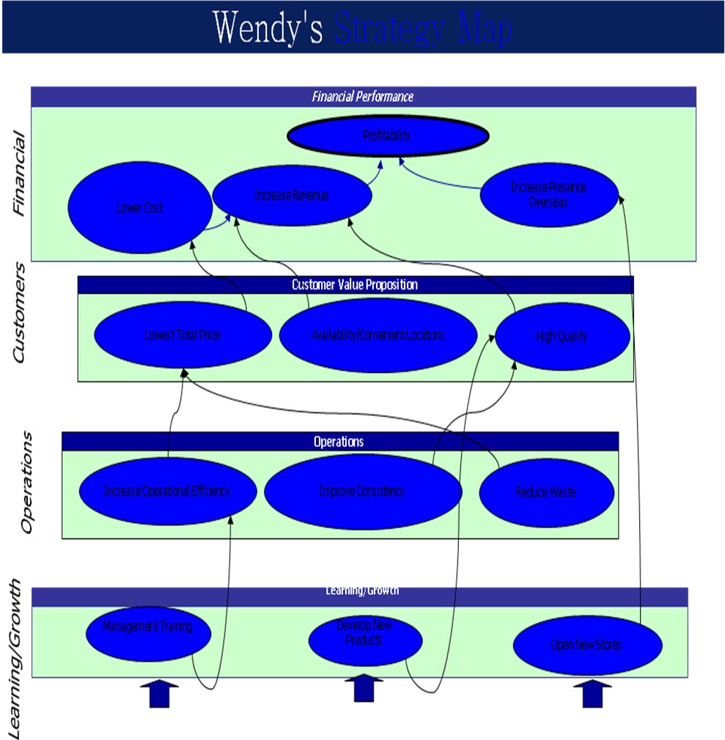

Appendix 2- Balanced Scorecard

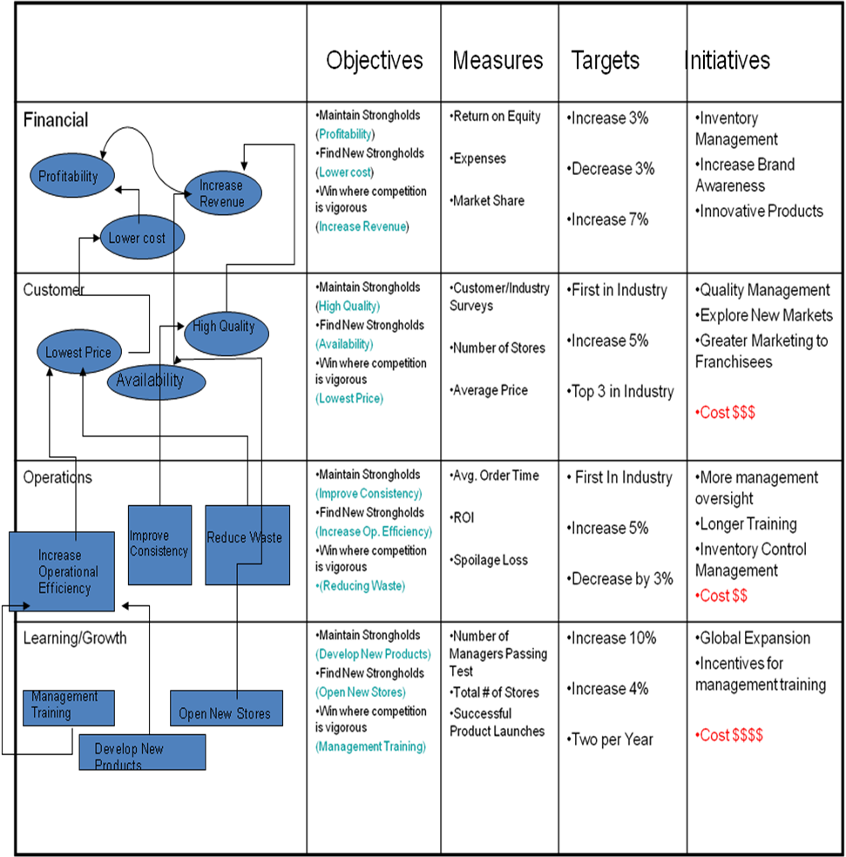

“The Wendy’s Story”, Wendy’s.com. date accessed 12/04/2008 < http://www.wendysarbys.com/about/our-brands>
“Our Brand: Wendy’s”, Wendysarbys.com. date accessed 12/08/2008, < http://www.wendysarbys.com/about/our-brands>

